Unit 6 Look at my balloon
Story time:
red green pink blue
A pink balloon, please.
Look at my balloon.
It’s blue.
It’s nice.
Rhyme time:
Balloon, balloon
比比谁最聪明★
A …, please. (颜色+物品名称)
Look at my ...
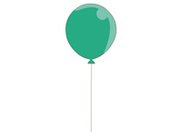
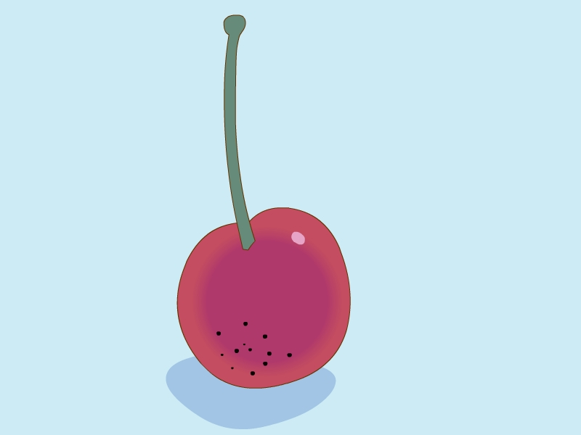
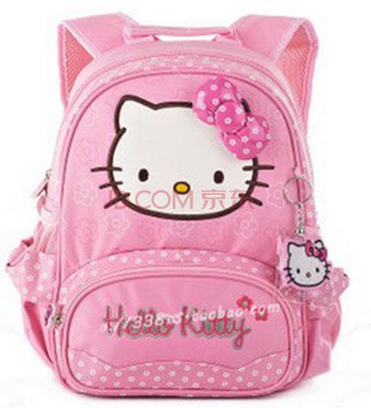
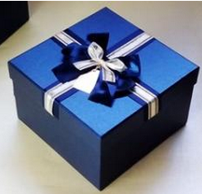
It’s ...

